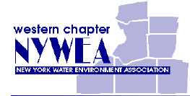
The NYWEA Western Chapter
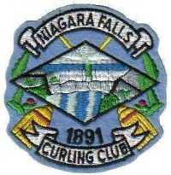
Young Professionals Committee is proud to announce our Winter Social event at:

NIAGARA FALLS
CURLING CLUB
5801 Morrison Street
Niagara Falls, ON
Saturday, February 18, 2012
2:30 PM-5:30 PM
(2:15 PM Check-in)
- Basic curling instruction included
- Food will be provided
- Cash bar available on site

Cost to YPs and Student Members is only $10.00/person
Thanks to the generosity of the Western Chapter Board.

Family and Friends (Ages 12 and Up) Are Invited at a Cost of $25.00/person

This is a great opportunity for young water/wastewater professionals and students to network with colleagues, and to play this Olympic Sport. Hope to see you there!

The Young Professionals Committee extends the invitation to the NYWEA Western Chapter Board Members.

Please carry in a pair of clean, dry running shoes. Street shoes and boots will not be permitted.
It is suggested that you wear warm, layered, loose-fitting clothing; you may also want to bring a hat and gloves.
All will be required to sign waivers provided by both NYWEA and the Club for participation in this event.
Please RSVP to Rosaleen Nogle (rosaleen.nogle@erie.gov) by February 4, 2012.

